**Important Links**

Document Vs Sentence Vs Aspect Level

<https://www.google.com/imgres?imgurl=https%3A%2F%2Fwww.intechopen.com%2Fmedia%2Fchapter%2F53756%2Fmedia%2FF1.png&imgrefurl=https%3A%2F%2Fwww.intechopen.com%2Fchapters%2F53756&tbnid=gGXawy9KONRMOM&vet=12ahUKEwjgkb2yvvnxAhUSZSsKHWRSCisQMygXegUIARDKAQ..i&docid=pUQitc0Nw_uIBM&w=591&h=566&q=sentence%20level%20sentiment%20mining&ved=2ahUKEwjgkb2yvvnxAhUSZSsKHWRSCisQMygXegUIARDKAQ>

Understanding the Disconnect Between Consumers and the Stock Market

<https://www.visualcapitalist.com/understanding-the-disconnect-between-consumers-and-the-stock-market/>

Recent Advances in Language Model Fine-tuning

<https://ruder.io/recent-advances-lm-fine-tuning/>

10 Leading Language Models For NLP In 2021

<https://www.topbots.com/leading-nlp-language-models-2020/>

Top 5 GPT-3 Successors You Should Know in 2021

<https://towardsdatascience.com/top-5-gpt-3-successors-you-should-know-in-2021-42ffe94cbbf>

quillbo

<https://quillbot.com/>

Momentum and Reversion

<https://www.linkedin.com/pulse/momentum-reversion-mukul-pal/?trk=read_related_article-card_title>

Mean-reversion vs. Momentum Strategies

<https://www.quantshare.com/blog-497-mean-reversion-vs-momentum-strategies>

When do you use mean reversion versus momentum strategy?

<https://www.quora.com/When-do-you-use-mean-reversion-versus-momentum-strategy>

Explain Your Model with the SHAP

<https://towardsdatascience.com/explain-your-model-with-the-shap-values-bc36aac4de3d>

The Data Science of K-Pop: Understanding BTS through data and A.I.

<https://towardsdatascience.com/the-data-science-of-k-pop-understanding-bts-through-data-and-a-i-part-1-50783b198ac2>

**All you need for your NLP search**

[**https://index.quantumstat.com/**](https://index.quantumstat.com/)

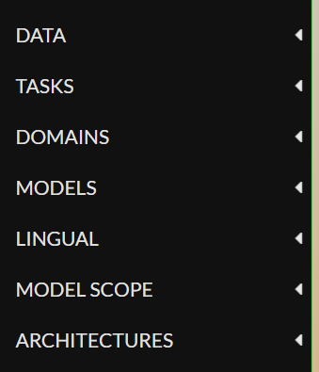 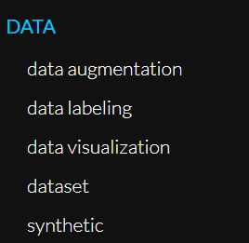 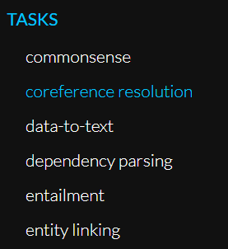 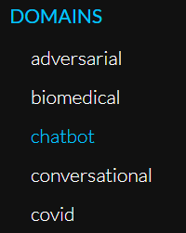 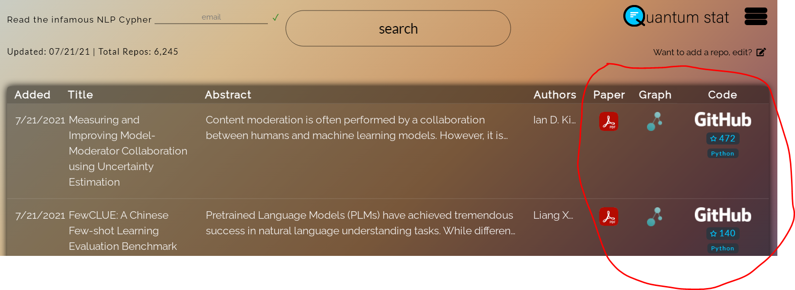

Difference between Zero short, One short and Few short models

<https://blog.floydhub.com/n-shot-learning/>

<https://research.aimultiple.com/few-shot-learning/>